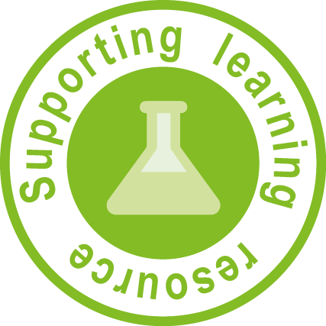

Weather measurement: Teacher note
Scientists learn about the weather by taking measurements. A variety of instruments are used to make observations. These include:
- a barometer which measures atmospheric pressure (how hard the weight of air particles press on an area on Earth’s surface). Atmospheric pressure is measured in hPa (hectopascals).
- an anemometer measures wind speed (how fast or slow the air is moving) via the cups that catch the wind. Wind speed is measured in km/h (kilometres per hour).
- a weather vane measures the direction the wind is blowing.
- a thermometer measures air temperature.
- a sling psychrometer measures relative humidity.
- a rain gauge measures the amount of rain that has fallen oven a given time.
- a weather buoy collects weather data in the ocean.
- a weather balloon measures the weather in the atmosphere.
- weather satellites photograph and track weather conditions of Earth.
These instruments collect data about wind speed, air pressure, temperature and humidity and provide scientists with data they can interpret to make predictions about weather events (e.g. storms, cyclones and rain events). The Australian Bureau of Meteorology presents data collected in tables and graphs to inform the public about the daily weather.

See the website Queensland observations (Australian Government, Bureau of Meteorology) http://www.bom.gov.au/qld/observations/index.shtml

Constructing a barometer

This activity is to highlight that the function of the barometer is to measure air pressure. It should demonstrate if the weather has changed during the observation period:
- When the outside pressure is high (i.e. air particles are further apart), the balloon will be sucked down into the bottle as the pressure in the bottle is lower pushing the straw pointer up higher on the ruler. High pressure usually indicates the weather is fine.
- When the outside pressure is lower (i.e. air particles are closer together) the balloon will be stretched on the bottle as the pressure in the bottle is higher. This pushes the straw pointer lower on the ruler. Low pressure usually means there is more chance of rain.
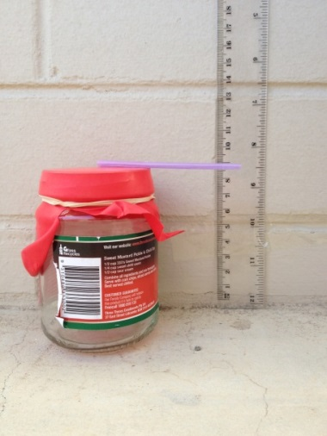 | 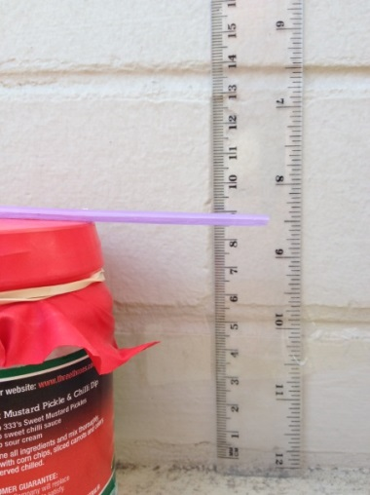 | 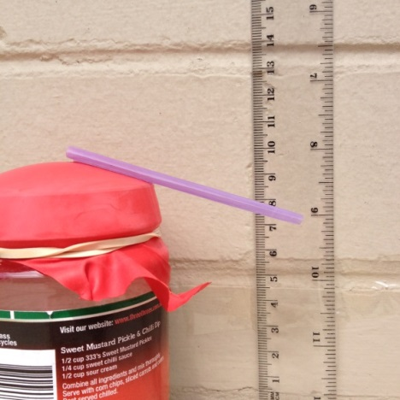
Additional information can be found on the website Balloon barometer — Science fair projects http://www.livescience.com/40664-balloon-barometer-science-fair-project.html

Constructing an anemometer
This activity is to highlight that the function of the anemometer is to measure wind speed and should demonstrate that as the wind increases, the string is blown off the centre-line and away from the starting position. | 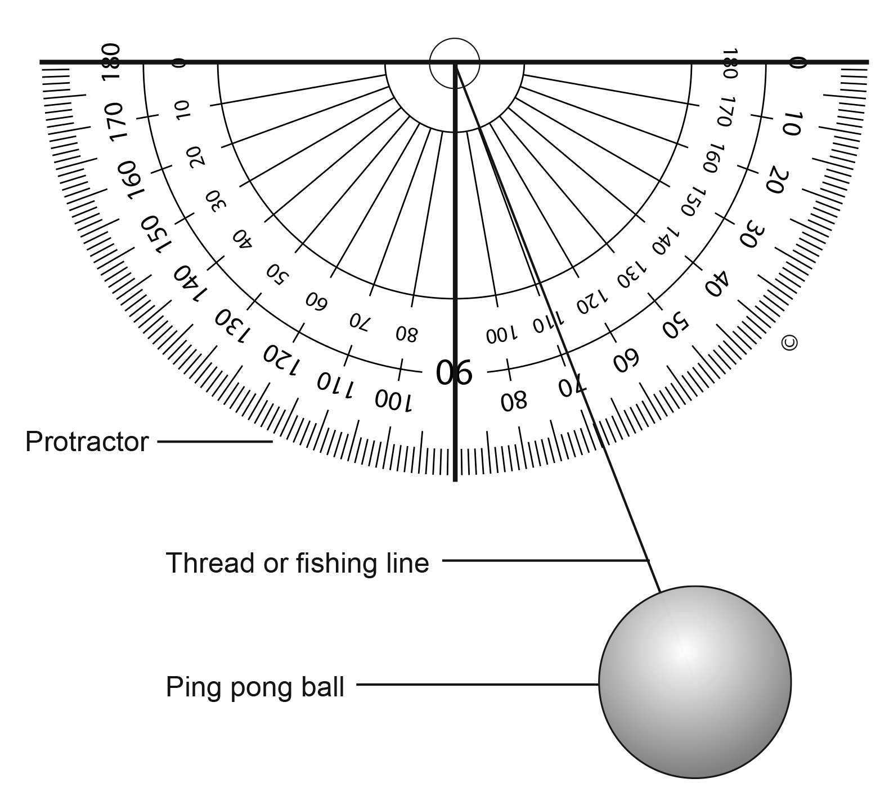
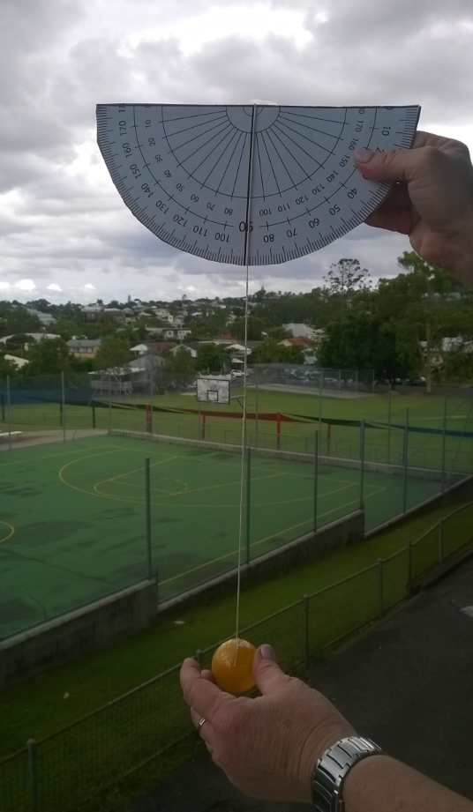 |  | 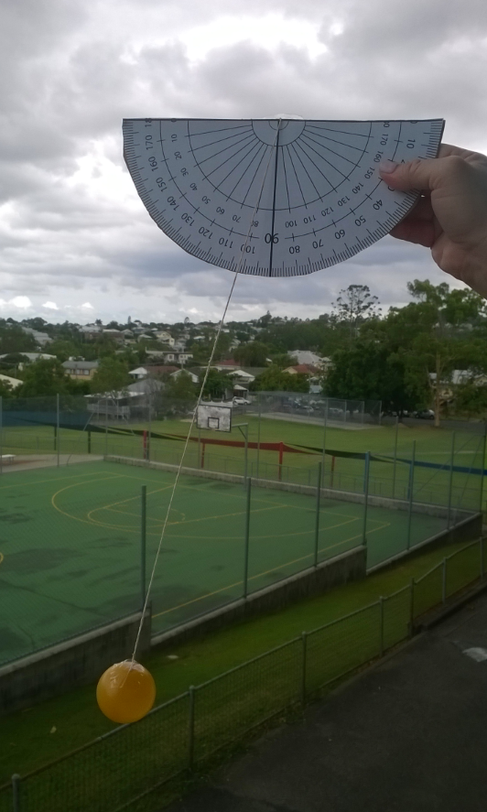

Additional information can be found at the website Worksheet 16: Activity — Measuring wind speed (Australian Government, Bureau of Meteorology) http://www.bom.gov.au/lam/Students_Teachers/Worksheet16.shtml

